**HOSPITAL MANAGEMENT SYSTEM**

ABSTRACT:

A hospital is a [health care](https://en.wikipedia.org/wiki/Health_care) institution providing [patient](https://en.wikipedia.org/wiki/Patient) treatment with specialized [health science](https://en.wikipedia.org/wiki/Medical_Science) and auxiliary healthcare staff and medical equipment. Hospitals are usually distinguished from other types of medical facilities by their ability to admit and care for inpatients whilst the others, which are smaller, are often described as [clinics](https://en.wikipedia.org/wiki/Clinics).

Hospitals are largely staffed by professional [physicians](https://en.wikipedia.org/wiki/Physician), [surgeons](https://en.wikipedia.org/wiki/Surgeon), [nurses](https://en.wikipedia.org/wiki/Nurse), and [allied health practitioners](https://en.wikipedia.org/wiki/Allied_health_professions), whereas in the past, this work was usually performed by the members of founding religious orders or by [volunteers](https://en.wikipedia.org/wiki/Volunteering).

Hospital Management system includes registration of patients, storing their details into the system, and also booking their appointments with doctors. Hospital Management System is an organized computerized system designed and programmed to deal with day-to-day operations and management of hospital activities.

Hospital Management System is a system enabling hospitals to manage information and data related to all aspects of healthcare – processes, providers, patients, and more, which in turn ensures that processes are completed swiftly and effectively.

OBJECTIVE:

* To promote awareness among functionaries involved in Health and Hospital Management.
* To promote research in the field of Health and Hospital Management.
* To improve the efficiency of Health Care delivery Systems.
* To promote the development of high quality hospital services and community health care.

STRUCTURE OF TABLES

HOSPITALS:

This table contains the details of the hospitals which includes serial number, name, city, contact, department, etc.

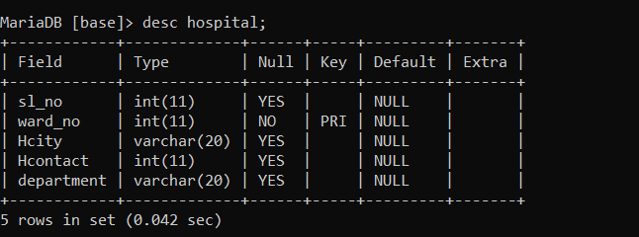

PHARMACY:

This table contains the details of all the pharmacy such as their id, name, dosage details, patient_id, etc.

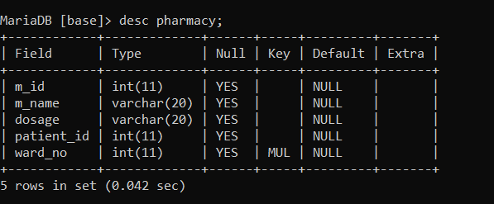

STAFFS:

This table contains the details of all the staffs such as their name, age, salary, designation, etc.

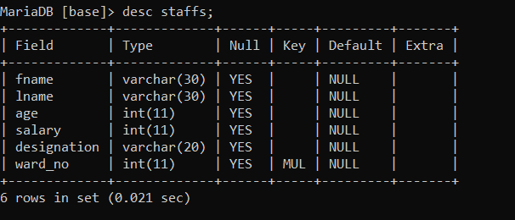

PATIENTS:

This table contains the details of all the patients such as their id, name, gender, age, etc.

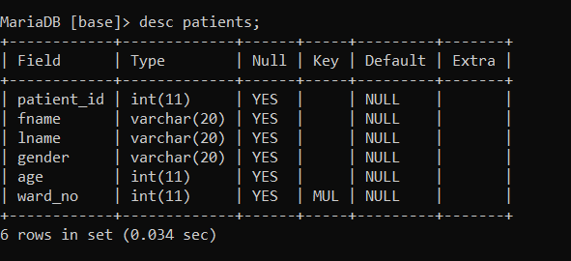

CONTENTS OF TABLES

HOSPITALS:

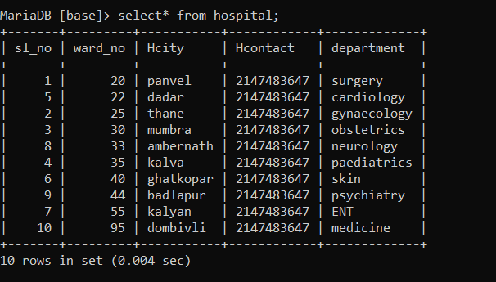

PHARMACY:

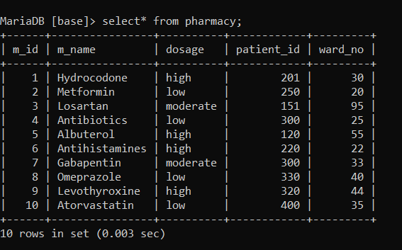

STAFFS:

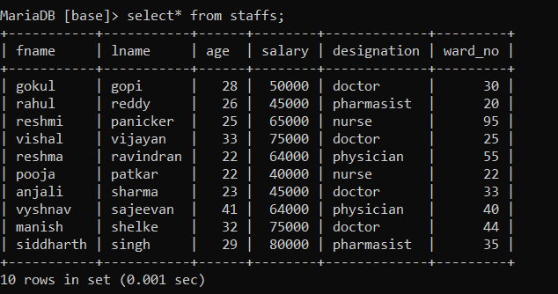

PATIENTS:

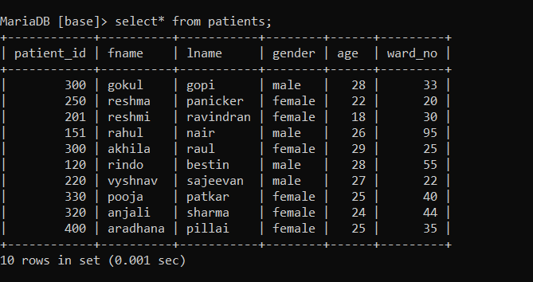

SUBQUERIES

1.Show all the details of all the Staffss working in the hospital having salary > 50000

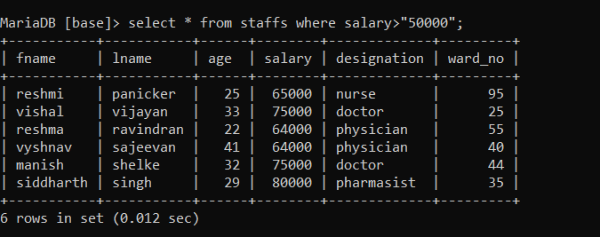

2.Show all the details of the patient having patient_id as 250

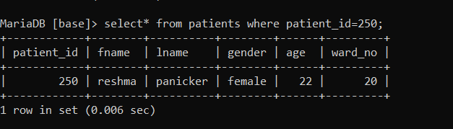

3.Show all the details of the doctors and nurses working in the hospital .

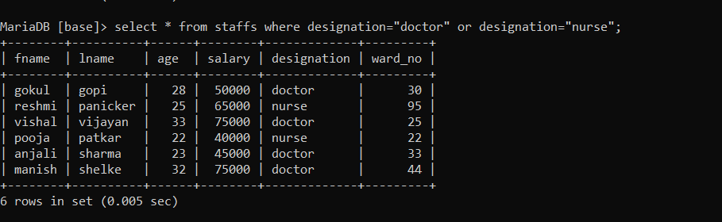

JOINS

1.Display all the details of staffs and patients in one table.

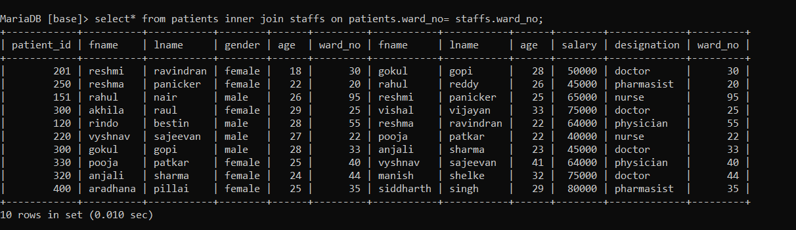

2.Display all the details of patients and common details of staffs.

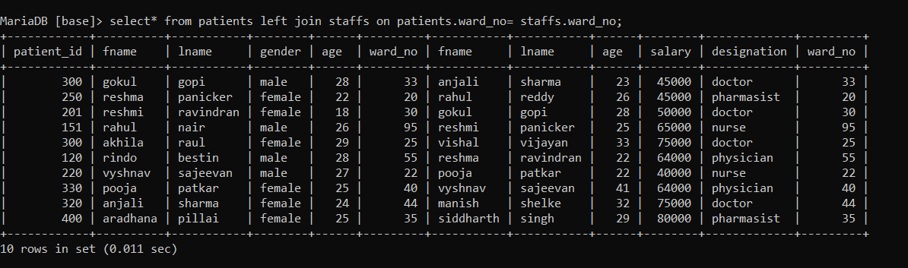

3.Display all the details of staffs and common details of patients.

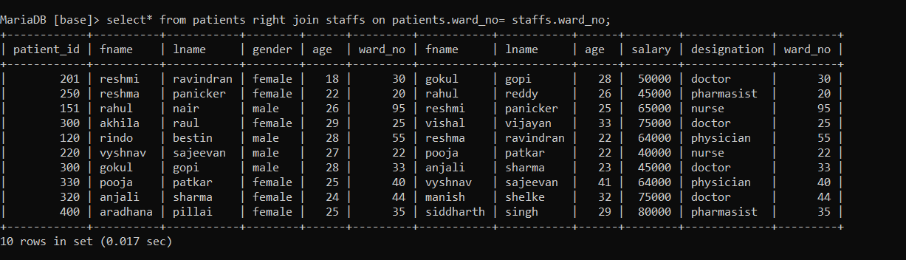

VIEWS

1.create a table to select fname of the person having designation as a nurse.

create view status as select fname,Designation from staffs where designation="nurse";

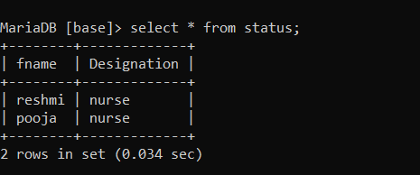

2.create a table to select non vaccinated patients of age <=25.

create view nonvaccinated as select patient_id,fname,ward_no from patients where age<="25";

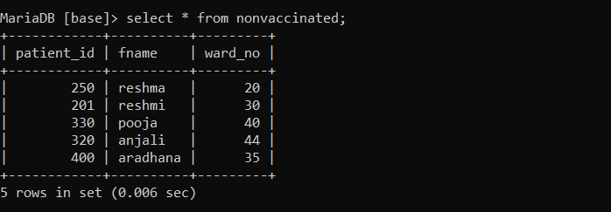

3.create a table to select high dosage medicines from pharmacy.

create view highdosage as select m_id,m_name,ward_no from pharmacy where dosage="high";

